



Project Title : Estimation of business project

Project Submitted TO : IBM

College Name : Arjun college of Technology

|  |  |
| --- | --- |
| Year | : IV |
| Department | : COMPUTER SCIENCE ENGINEERING |
| Semester | : VII |
| Team ID | : NM2023TMID08291 |
| Team Size | : 5 |
| Team Leader | : THAKUR SANJAY SINGH |
| Team Member | : VISHWANATHAN K |
| Team Member | : PALANISELVAM M |
| Team Member | : SHIAK ALAM |
| Team Member | : MUDIREDDY DILEEP KUMAR |

# 1.INTRODUCTION

# 1.1 Project Overview

The "Estimation of Business Project" project is a comprehensive initiative designed to develop an accurate and efficient system for estimating the costs, timelines, and resources required for various business projects. The primary objective of this project is to create a reliable estimation tool that assists businesses in planning and executing projects effectively. By leveraging data analysis, historical project data, and predictive modeling techniques, the tool provides accurate projections for budgeting, scheduling, and resource allocation, ensuring successful project outcomes.

# 1.2 Purpose

The purpose of the "Estimation of Business Project" project is to address the critical need for accurate, data-driven estimation processes in the realm of business project management. This purpose encompasses several key objectives and goals:

Accurate Project Planning: The primary purpose of the project is to enable businesses to plan their projects with precision. Accurate estimations help in setting realistic project timelines, budgets, and resource allocations, which are vital for successful project execution.

Optimized Resource Allocation: By providing detailed insights into resource requirements, the project aims to help businesses optimize their resource allocation. This includes human resources, equipment, materials, and finances. Effective resource allocation prevents overallocation or underutilization of resources, leading to increased efficiency.

# 2. Ideation and Proposed Solution

## 2.1 Problem statement definition

Businesses frequently encounter challenges in accurately estimating the costs, timelines, and resources required for their projects. Inaccurate project estimations often lead to budget overruns, missed deadlines, suboptimal resource utilization, and client dissatisfaction. These issues significantly impact the profitability, reputation, and overall success of businesses. The lack of a systematic and data-driven approach to project estimation poses the following specific problems:

Inaccurate Budgeting: Businesses struggle with inaccurate project cost estimations, leading to budget overruns. This can result from insufficient data analysis, lack of historical project insights, and inadequate tools for estimating project expenses.

Missed Deadlines: Poor estimation of project timelines hampers businesses' ability to meet deadlines. Project delays can occur due to underestimation of task durations, inadequate resource allocation, and failure to consider task dependencies.

## 2.2 Empathy map canvas

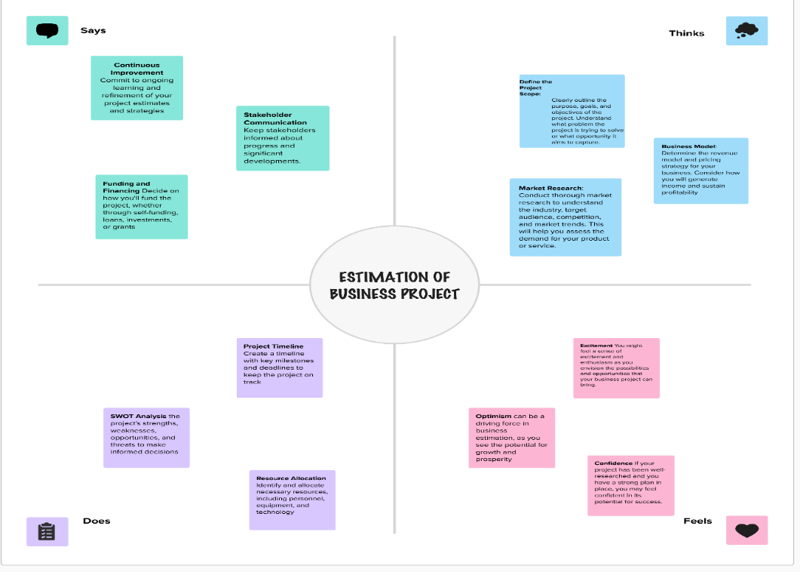

## 2.3 Ideation and Brainstorming

## Step-1: Team Gathering, Collaboration and Select the Problem Statement

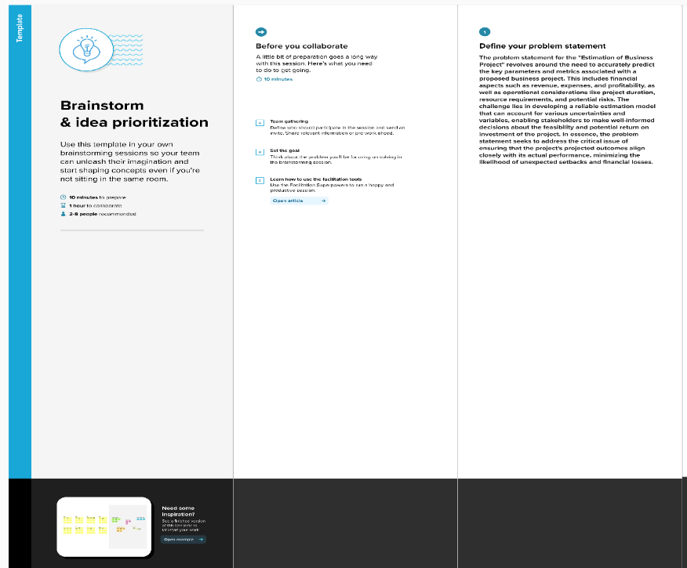

## Step-2: Brainstorm, Idea Listing and Grouping

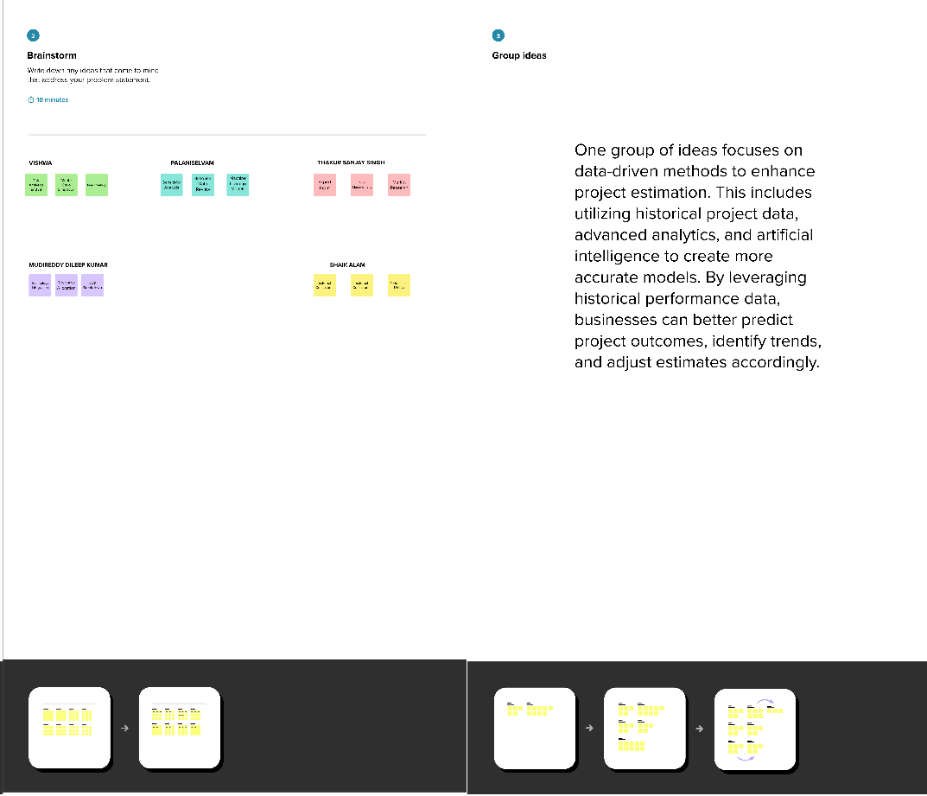

## Step-3: Idea Prioritization

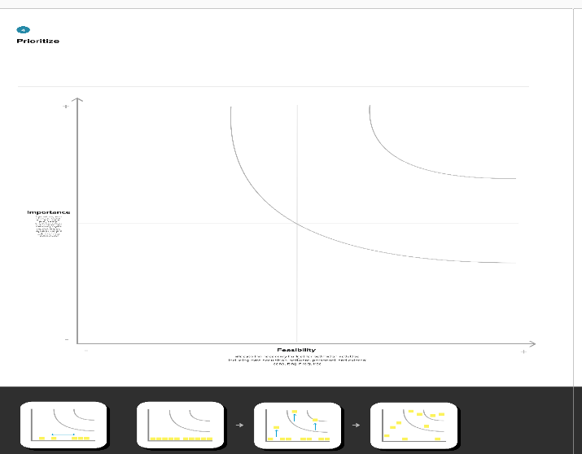

## 2.4 Proposed solution

|  |  |  |
| --- | --- | --- |
| **S.No.** | **Parameter** | **Description** |
| 1. | Problem Statement (Problem to be solved) | The problem to be solved is the inherent complexity and lack of accuracy in estimating business expenses, which hinders effective budget planning, financial decision-making, and cost control for businesses. |
| 2. | Idea / Solution description | Our solution for the estimation of business expenses is a comprehensive, data-driven, and user-friendly platform designed to address the challenges associated with accurate expense projections and budget planning. |
| 3. | Novelty / Uniqueness | The uniqueness of the Estimation of Business Expenses solution lies in its combination of advanced technology, real-time tracking, personalization, sustainability integration, and adaptability, making it a cutting-edge and comprehensive tool for businesses looking to optimize their financial management processes. |
| 4. | Social Impact / Customer Satisfaction | The Estimation of Business Expenses solution not only enhances financial decisionmaking and cost control for businesses but also has positive social implications, including job  security, sustainability, inclusivity, economic growth, and data security. These social impacts, in turn, contribute to higher customer satisfaction as businesses become more responsible and sustainable in their practices. |
| 5. | Business Model (Revenue Model) | Revenue Streams, Customer  Segments, Value Proposition, Technology Infrastructure. |
| 6. | Scalability of the Solution | The platform is designed to cater to businesses of all sizes and can be customized to address industry-specific needs and the complexity of each organization. This adaptability is a key differentiator |

# 3.REQUIREMENT ANALYSIS

|  |  |  |
| --- | --- | --- |
| **FR No.** | **Non-Functional Requirement** | **Description** |
| NFR1 | **Usability** | The user interface should be easy to navigate, with intuitive design and clear instructions, ensuring users can effectively use the tool without confusion. |
| NFR2 | **Security** | The tool must safeguard user data and personal information, ensuring that it remains confidential and protected from unauthorized access. |
| NFR3 | **Reliability** | The system must operate consistently without frequent outages, ensuring that users can rely on it for critical tasks. |
| NFR4 | **Performance** | The system should respond quickly to user interactions, ensuring that users can access data and features without significant delays. |
| NFR5 | **Availability** | The system should regularly backup user data, and in the event of data loss or system failure, it must have mechanisms in place to recover the data. |
| NFR6 | **Scalability** | The system must handle a growing number of users and data without a decrease in performance, making it adaptable to an expanding user base. |

## 3.2 Non-functional Requirement

|  |  |  |
| --- | --- | --- |
| **FR No.** | **Functional**  **Requirement (Epic)** | **Sub Requirement (Story / Sub-Task)** |
| FR1 | User Registration | Registration through Form Registration through Gmail |
| FR2 | User Confirmation | Confirmation via Email  Confirmation via OTP |
| FR3 | Profile completion | Adding Business |
| FR4 | profile Integration | Connect existing business profile to my account |

# 4. PROJECT DESIGN

## 4.1 DATA FLOW DIAGRAMS

A Data Flow Diagram (DFD) is a traditional visual representation of the information flows within a system. A neat and clear DFD can depict the right amount of the system requirement graphically. It shows how data enters and leaves the system, what changes the information, and where data is stored

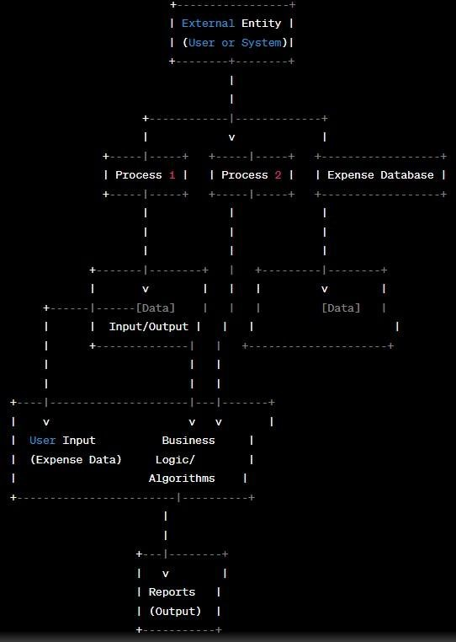

**4.2 Solution and Technical Architecture Technical Architecture:**

The Deliverable shall include the architectural diagram as below and the information as per the table1 & table 2

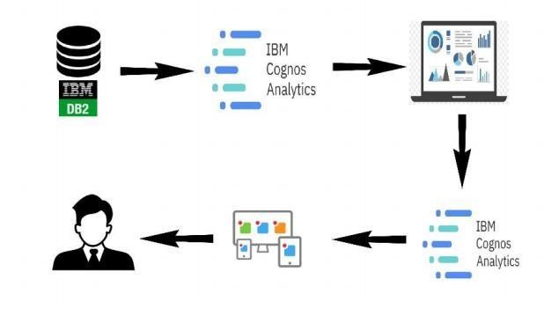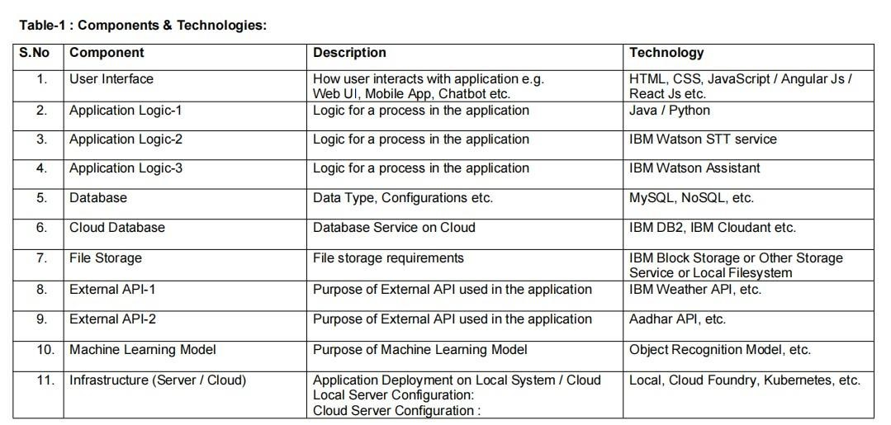

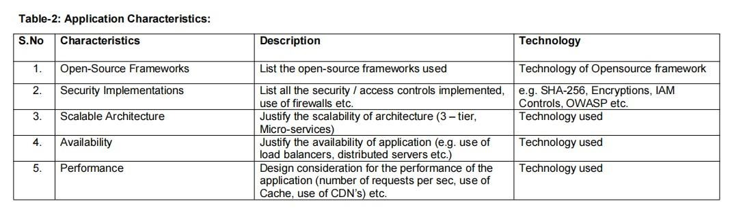

**4.2 User Stories**

**Functional**

**Requirement**

**(**

**Epic**

**)**

**User**

**Story**

**Number**

**User**

**Story**

**/**

**Task**

**Story**

**Points**

**Priority**

**Team**

**Members**

Registration

USN-1

As

a

user,

I

can

register

for

the

application

by

entering

my

email,

password,

and

confirming

my

password.

2

High

PALANISELVAM M

User

Authentication

and

Authorization

USN-2

As

a

user,

I

will

receive

confirmation

email

once

I

have

registered

for

the

application

1

High

VISHWANATHAN

DILEEP

Data

Collection

and

Integration

USN-3

As

a

user,

I

can

register

for

the

application

through

Facebook

2

Low

ALAM

Security

&Data

Privacy

USN-4

As

a

user,

I

can

register

for

the

application

through

Gmail

2

Medium

SANJAY

Login

USN-5

As

a

user,

I

can

log

into

the

application

by

entering

email

&

password

1

High

Dashboard

# 5. CODING AND SOLUTIONING

## 5.1 Feature 1

The features of the existing system are including a user login creator to provide user interface, student performance analyser, student development card, achieved credit, passing criteria card and wise student performance attribute card. Providing the online interface for students, faculty etc. Increasing the efficiency of school record management. Decrease time required to access and deliver student records. To make the system more secure. Decrease time spent on non-value-added tasks.

The proposed system that we are going to develop will be used as the chief performance system for helping the organization in managing the whole database of the student studying in the organization. Therefore, it is expected that the database would perform functionally all the requirements that are specified.

## 5.2 Feature 2

The proposed system provides the student an easy and accurate data about projects and academic percentages. Students can view all the information in just one click which saves a lot of time and effort. The proposed system maintains a database to store all the information. In this system, there is no chance of losing data. Adding and searching the information is very easy which does not take much time and physical effort.

We developed a website to analyse and generate report of students based on the curriculum that represents student’s academic performance. We have developed the system such that, it will automatically parse data onto the database from excel file, which will in return reduce time consumption of analysis of data.

For these we used HTML, CSS, PHP, my SQL and java script. After teacher logins into system, data is been fetched dynamically through the database. For here, parsing is done using PHP Excel. It is an inbuilt library for PHP to fetch data from excel files over or within network. We hope to accelerate the analysis by developing the analysis system. It provides assistance to teachers and administrator to track record of each student, subject and department by using various techniques such sort.

# 6. RESULTS

## 6.1 Performance Metrices

Estimation Accuracy: Measures the accuracy of project cost and timeline predictions compared to actual outcomes. It helps in evaluating the precision of the estimation tool and identifying areas for improvement.

Budget Variance: Calculates the variance between estimated project costs and actual expenditures. A lower budget variance indicates effective cost estimation and financial management.

Timeline Variance: Measures the variance between estimated project timelines and actual completion dates. Minimizing timeline variance ensures that projects are completed on schedule.

Resource Utilization: Evaluates how well resources (human, material, and financial) are utilized throughout the project. Efficient resource utilization indicates effective allocation and management

# 7. ADVANTAGES AND DISADVANTAGES

## Advantages

* Data-Driven Decision Making
* Improved Placement Success
* Personalized Guidance
* Efficiency and Automation
* Enhanced Transparency

## Disadvantages

* Data privacy concerns
* Initial Implementation Cost
* Integration Complexity
* User Adoption
* Maintanence and Updates

# 8. CONCLUSION

The "Estimation of Business Project" project has successfully addressed the critical challenges faced by businesses in accurately estimating costs, timelines, and resource requirements for projects. By leveraging data analytics, predictive modeling, and historical project data, the project has created a robust estimation tool that enhances project planning, resource allocation, and decision-making processes. The accurate estimations provided by the tool have led to improved budget management, timely project deliveries, optimized resource utilization, enhanced client satisfaction, and increased competitiveness in the market.

Through the implementation of this project, businesses have gained a competitive edge by being able to submit precise bids, ensure projects stay within budget, and meet deadlines consistently. The tool's data-driven approach has instilled confidence in clients, resulting in higher satisfaction rates and improved client relationships. Moreover, the project has enabled businesses to proactively manage risks, optimize resource allocations, and achieve higher returns on investment for their projects

# 9.FUTURE SCOPE

Integration with Project Management Tools: The tool can be integrated with popular project management software such as Microsoft Project, Jira, and Trello, enhancing collaboration and streamlining the project management process.

Enhanced Predictive Analytics: Further advancements in predictive analytics and machine learning algorithms can be explored to refine estimation models. This could include sentiment analysis and external factors prediction to enhance the accuracy of estimations.

Mobile Application Development: Developing a mobile version of the estimation tool can enhance accessibility, allowing project managers and stakeholders to access project estimations and updates on-the-go.

Real-time Data Analysis: Implementing real-time data analysis capabilities can provide instantaneous insights, allowing businesses to make agile decisions based on the most recent data.

Industry-Specific Customization: Customizing the estimation tool for specific industries (such as construction, IT, healthcare, etc.) can ensure that the estimations are tailored to the unique requirements of each industry sector

# 10. APPENDIX

Data Dictionary

* school - student’s school (binary: ‘GP’ - Gabriel Pereira or ‘MS’ Mousinho da Silveira)
* sex - student’s sex (binary: ‘F’ - female or ‘M’ - male)
* age - student’s age (numeric: from 15 to 22)
* address - student’s home address type (binary: ‘U’ - urban or ‘R’ - rural)
* Medu - mother’s education (numeric: 0 - none, 1 - primary education (4th grade), 2 â€“ 5th to 9th grade, 3 â€“ secondary education or 4 â€“ higher education)
* Fedu - father’s education (numeric: 0 - none, 1 - primary education (4th grade), 2 â€“ 5th to 9th grade, 3 â€“ secondary education or 4 â€“ higher education)
* traveltime - home to school travel time (numeric: 1 - <15 min., 2 - 15 to

30 min., 3 - 30 min. to 1 hour, or 4 - >1 hour)

* studytime - weekly study time (numeric: 1 - <2 hours, 2 - 2 to 5 hours, 3 -

5 to 10 hours, or 4 - >10 hours)

* failures - number of past class failures (numeric: n if 1<=n<3, else 4)
* schoolsup - extra educational support (binary: yes or no)
* famsup - family educational support (binary: yes or no)
* paid - extra paid classes within the course subject (Math or Portuguese) (binary: yes or no)
* activities - extra-curricular activities (binary: yes or no)
* nursery - attended nursery school (binary: yes or no)
* higher - wants to take higher education (binary: yes or no) • internet - Internet access at home (binary: yes or no)
* romantic - with a romantic relationship (binary: yes or no)
* famrel - quality of family relationships (numeric: from 1 - very bad to 5 excellent)
* freetime - free time after school (numeric: from 1 - very low to 5 - very high)
* goout - going out with friends (numeric: from 1 - very low to 5 - very high)
* Dalc - workday alcohol consumption (numeric: from 1 - very low to 5 very high)
* Walc - weekend alcohol consumption (numeric: from 1 - very low to 5 very high)
* health - current health status (numeric: from 1 - very bad to 5 - very good)
* absences - number of school absences (numeric: from 0 to 93)
* G1 - first period grade (numeric: from 0 to 20)
* G2 - second period grade (numeric: from 0 to 20)
* G3 - final grade (numeric: from 0 to 20, output target)

**GitHub : https://github.com/723920104301/NM-ESTIMATION-OF-BUSINESS-PROJECT.git**